**WRITING SECTION (16 pts.)**

**A. Fill the gaps in the text with a suitable connector from the box and a sentence (a – d). The sentences are NOT in the correct order. Use each connector and sentence only ONCE. Be careful! There is ONE extra connector and ONE extra sentence. (2 pts. each; 6 pts.)**

My name is Petra **(0) *e.g.*** an d I’m an op er a sin ger. My husband’s name is George. He is an

opera singer, too. We both work at the San Francisco Opera Company. We have a very busy daily routine. In the morning, we go to the opera building. We practice with the other musicians all morning. Then we have lunch. We want to be healthy

(1) . We also do sports. I like running and swimming

(2) .

He does yoga instead. In the evening, we read books

(3) _. Our favorite movie is *The Shape of Water* by Guillermo del Toro.

**or because but so  ~~and~~**

a. We watch a movie.

b. George doesn’t like those sports.

c. I like playing computer games. d. We usually eat fish and salad.

~~e.~~  ~~I’m an op er a sin ger.~~

**PLEASE TURN OVER**

**LANGUAGE SECTION (25 pts.)**

1. **Read the text below. Fill each gap in the text with the correct form of the verb in parentheses.**

I am an archaeology student at Boston University. I (1) (like) archaeology very much because I (2) (learn / usually) a lot about ancient cultures. At the moment, I (3) (take) a course about antique civilizations. The course is very interesting. The instructor (4) (know) everything about the subject, and she (5) (not / give / always) us homework assignments.

Yesterday, the instructor (6) (give) us information about the island of Atlantis. It is a very interesting subject: over two thousand years ago, the Greek writer Plato (7) (write) about Atlantis. It (8) (be) a very rich island. It had a big city with many great buildings and a beautiful golden temple at the center of the island.

At first, the people of Atlantis had a lot of happiness and good luck. Then their luck (9) (start) to change. They had many things, but they (10) (not / be) happy. Because the people of Atlantis were greedy (they wanted a lot of things), the gods (11) (become) angry.

They (12) (break) the city’s buildings. Finally, the whole island of Atlantis (13) (go) down into the sea.

Learning a lot of information about this island was very interesting. Therefore, when I (14) (wake up) this morning, I decided to go to the library and do some more research in the afternoon. Now, I (15) (have) lunch with my friend, and then we (16) (go) to the library to learn about this ancient island together.

**B. Read the conversation below. Fill in the blanks with ONE WORD ONLY. (1 pt. each; 6 pts.)**

**Paula:** Hi… Are you lost? (1) you need help?

**Dave:** Yes, where’s the Museum of Modern Art? I don’t see it on the map.

**Paula:** Here. It’s (2) to the hospital on Westbourne Road.

**Nigel:** (3) do we get there?

**Paula:** Go down this road and turn left at the traffic lights. Then go straight on and turn left again, here. The museum is (4) the right. It’s (5) the cathedral and the hospital.

**Nigel:** Is it far?

**Paula:** It’s about a twenty-minute walk.

**Dave:** It’s far. Let’s take a taxi.

**Paula:** No, don’t take a taxi. Take the underground from Tottenham Station. Get off at Westbourne Station. The station is in front (6) the park. Visit the cathedral, too. It’s beautiful.

**Nigel:** OK, thanks.

**Paula:** No problem.

**C. Look at the information in the table. Write questions to get the answers. (2 pts. each; 6 pts.)**

Maia’s Dream Holiday and her Real Holiday

Maia’s dream is to go to the Maldive Islands for a holiday.

Dream holiday –

Maia wants this:

Maia wanted to go to the Maldives last winter. She didn’t go there because it was expensive. A trip to the Maldives costs $2,000.

Real holiday – Maia did this: Instead, Maia went to San Francisco for her holiday because her sister lives there.

1. last winter?

No, she didn’t.

2. ?

$2,000.

3. ?

To San Francisco.

**VOCABULARY SECTION (10 pts.)**

**Read the following short text. Fill each gap with a suitable word from the box. DO NOT change the forms of the words. Use each word only ONCE. Be careful! There are two extra words. (1 pt. each; 10 pts.)**

**forward allow departures part transport alone accidents wait unusual tour care around**

Hi. I’m Dr. Tarun Kumar Gahlot. I am a veterinarian. You know that veterinarians take (1) of animals. I’m a veterinarian only for camels, so my job is different from other veterinarians’

jobs. It’s a/an (2) job.

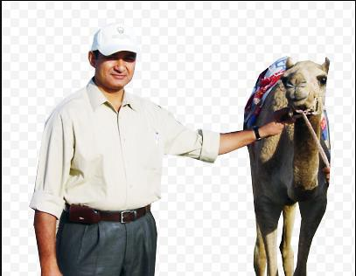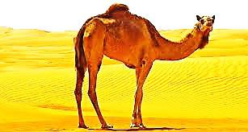

I live and work in Bikaner, Rajasthan in India. I’m not married; I live

(3) in a big house.

Because there are a lot of camels in Rajasthan, it’s a good place for

my work. People use camels to go from one place to another. When people don’t want to (4) for the bus for a long time, they use camels. Also, the roads in Rajasthan aren’t very safe. Cars and buses often have (5) on the roads. Because traveling on a camel is safe, camels are a popular type of (6) in Rajasthan.

Every year, camels in Rajasthan take (7) in a competition. Fast camels win the competition, and slow camels lose. The organizers don’t (8) everyone to be in the competition; only very good camel riders can enter. The people of Rajasthan look (9) to the competition all year. They want to see the camels run fast.

Visitors to Rajasthan like to watch the competition, too. There is also a

guided (10) on camels, and this is a very popular activity for visitors.

**a camel**

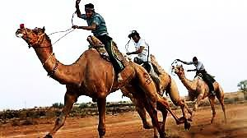

**Text I (17 pts.)**

**Read the text and answer the questions that follow.**

**Across Russia by Rail and by Road**

**1** Russia is a very big country. It is 9,000 kilometers from Moscow in the west to

Vladivostok in the east, and there are two ways to travel: by rail (train) and by road.

**By Rail: the Trans-Siberian Railway**

**2** Trains leave Moscow almost every day. Buy your tickets before you arrive in Moscow.

You can buy them online or from a travel agent in your city. There are two types of train trips on the Trans-Siberian Railway:

**3** *Travel non-stop for seven days.* With this kind of trip, travelers stay on the train all the time. **They** sleep and eat on the train. They can talk to other passengers, learn some words in Russian, and enjoy the views; the train travels through tall mountains, dark forests and beautiful deserts.

**4** *Stop on the way and stay in hotels.* On this kind of trip, travelers can get off the train and see the big cities. There are a lot of places to visit along the route. Perm is a famous city on the railway, and tourists often visit the Kungur Ice Cave near Perm. Another city near the railway is Novosibirsk. Novosibirsk is the main city in Siberia. There are museums, art galleries, theaters and a famous opera house **there**. Irkutsk and Ulan-Ude are towns in Siberia. From these towns, tourists take a bus or train to

Lake Baikal. The lake is 636 km long, and there are only four or five towns near it. It is a great place for sports activities. Diving, hiking and horse riding are all popular.

**By Road: the Trans-Siberian Highway**

**5** Are you adventurous1? Take the new Trans-Siberian Highway. Drive your car, or hitch- hike2 with Russian drivers in their cars and trucks. It sometimes rains or snows, so the road becomes very dangerous. Travel when the weather is good.

**6** When you finally arrive in Vladivostok, you can fly home or continue your trip: There is a boat to Japan every week.

**1 adventurous:** an adventurous person likes danger **2 hitch-hike:** to travel for free

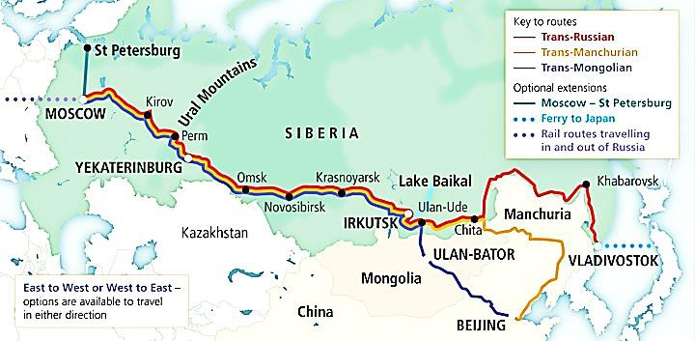

**A. What do the following refer to? (1 pt. each; 2 pts.)**

1. “They” (para. 3):

2. “there” (para. 4):

**B. Write the correct word or words to fill the blanks in the sentences. Be careful about the meaning. (1 pt. each; 5 pts.)**

*(para. 1 and 2)*

People can travel from Moscow to Vladivostok in two ways: one is by rail, and the other is by (1) . There are (2) _________________ from Moscow almost every day.

*(para. 3)*

Travelers on the Trans-Siberian Railway can see (3) , (4) and (5) from the train.

**C. Answer the following questions according to the information in the text. (2 pts. each; 10 pts.)**

1. Where can travelers buy tickets for the Trans-Siberian Railway? Write **two** places. a) b)

2. What do travelers visit near Perm?

.

3. How do travelers get to Lake Baikal?

.

4. Why is the Trans-Siberian Highway sometimes dangerous?

.

5. Where do boats go from Vladivostok?

.

**Text II (12 pts.)**

**Read the text and answer the questions that follow.**

**1** Mark Twain was an American author, journalist and lecturer. His real name was Samuel Langhorne Clemens. He lived from 1835 to 1910, but his stories are still famous today. Samuel grew up in Missouri, USA. At

that time, **it** was a new state in the United States. There were no big cities in Missouri then; there were only small towns.

**2** Samuel’s father was a lawyer, but he did not make a lot of money. Samuel had six brothers and sisters, so it was difficult for his father to feed the family. When Samuel was 11, his father died. Samuel left school and started work. First, he worked as an assistant to the printer at a local newspaper in Hannibal, Missouri. He printed the newspaper and read the news of the world at the same time. Later, he wrote some stories for the

newspaper. People liked his stories, so Samuel decided to go to the big cities in the East and work there. He went to New York City and Philadelphia when he was 18. He worked for different newspapers in **those cities**. He was successful, but he did not like the people in the East. He thought they were not friendly.

**3** In 1857, Samuel returned to Missouri.

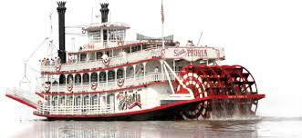

There, he learned to be a riverboat pilot on the Mississippi River, a

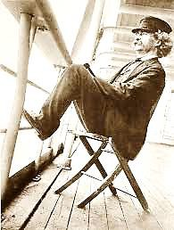

very big river in the US. He liked his job, and the Mississippi River stopped. Samuel needed another job.

**4** This time, Samuel went west to a new US territory, Nevada. He wanted to find a lot of silver in Nevada and get rich, but he did not have good luck. He did not find a lot of silver in Nevada, but he had good luck in another way. He wrote his first short story with his new pen name, Mark Twain. Mark Twain means “3.5m of water”. It is a term from Samuel’s riverboat years. Samuel’s new story, *Jim Smiley and His Jumping Frog*, was in newspapers all over the US. Samuel became famous with the name Mark Twain.

**5** People liked Mark Twain’s stories because he wrote about ordinary people. He did not usually write about rich people in cities. He wrote about people in the countryside or black people in the US. In his books, he made his characters talk like they talked in real life. This was unusual for writers at that time.

**6** Mark Twain’s most famous books are *The Adventures of Tom Sawyer* and *The Adventures of Huckleberry Finn*. Millions of people all over the world love to read these books. Samuel Clemens died on April 21, 1910 in Connecticut, USA. He was 74 years old.

1. “it” (para. 1) :

2. “those cities” (para. 2) :

**B. Answer the following questions according to the information in the text. (2 pts. each; 10 pts.)**

1. What was Samuel Clemens’ first job?

.

2. Why didn’t Samuel like the people in New York and Philadelphia?

.

3. Why did riverboat traffic on the Mississippi River stop?

.

4. What does “Mark Twain” mean?

.

5. Who did Mark Twain usually write his stories about?

.

**SFL/METU November 9, 2017**

**DBE**

**Testing Office**

**Mid-Term 01**

**BEGINNER GROUP**

**ANSWER KEY**

**WRITING SECTION (16 pts.) A. (2 pts. each; 6 pts.)**

1. **(,)** so we usually eat fish and salad (d)

2. **,** but George doesn’t like those sports (b)

3. **(,)** or (we) watch an arthouse move (a)

**LANGUAGE SECTION (25 pts.) A. (1 pt. each; 13 pts.)**

1. like

2. usually learn

3. am taking / ‘m taking

4. knows

5. doesn’t always give

6. gave

7. wrote

8. was

9. started

10. weren’t / were not

11. became

12. broke

13. went

14. woke-up

15. am having

16. are going to go

**B. (1 pt. each; 6 pts.)**

1. Do

2. next

3. How

4. on

5. between / near

6. of

**C. (2 pts. each; 6 pts.)**

1. Did Maia / she go to (the) Maldives

2. Where did Maia / she go for / on her holiday (instead)

**VOCABULARY SECTION (1 pt. each; 10 pts.)**

1. care

2. unusual

3. alone

4. wait

5. accidents

6. transport

7. part

8. allow

9. forward

10. tour

**READING SECTION (29 pts.)**

**Text I (17 pts.)**

**A. (1 pt. each; 2 pts.)**

1. Travelers / Passengers

2. in Novosibirsk

**B. (1 pt. each; 5 pts.)**

1. road / car / highway / (the) Trans-Siberian Highway

2. trains

3 – 5. **In any order:** (tall) mountains (dark) forests (beautiful) deserts

**C. (2 pts. each; 10 pts.)**

1. **1 pt. each**

a) (They can buy them / tickets) online

b) (They can buy them from a) travel agent (in their city)

2. (They / Travelers / Tourists visit)(the) Kungur Ice Cave

3. (They / Travelers / Tourists) take a bus or a train (from Irkutsk or Ulan-Ude) By bus or by train

4. (Because) it sometimes rains or snows/

It sometimes rains or snows, so the road becomes very dangerous:

5. (They / Boats go) to Japan

**Text II (12 pts.)**

**A. (1 pt. each; 2 pts.)**

1. Missouri (, USA)

2. New York (City) and Philadelphia

**B. (2 pts. each; 10 pts.) C.**

1. (He worked as an / He was an) assistant (to the) printer (at a local newspaper in

Hannibal, Missouri)

He worked at a local newspaper (in Hannibal, Missouri)

(He was a / He worked as a / an assistant) newspaper printer

He printed the / a newspaper

2. (Because) he thought they weren’t friendly

3. (Because) the US Civil War started

4. (It means) “3.5m of water”

5. (He / Mark Twain usually wrote his stories about) ordinary people / people in the countryside / black people (in the US)